CS351IT- Human Computer Interaction

Second Semester 1446



**Title: Signature Pieces**



|  |  |  |
| --- | --- | --- |
| Student Number | Student Name | No. |
| 444009057 | Aleen Alotaibi | 1 |
| 444009259 | Lama Alshaiban | 2 |
| 444009063 | Elaf AlOtaibi | 3 |
| 444009188 | Reema Alharbi | 4 |

**Abstract:**

simplify furniture shopping through an online store with augmented reality (AR) features, Users can visualize how furniture will look in their room before purchasing, helping them make better decisions, avoiding common problems, and ensuring a seamless, dynamic, and enjoyable shopping experience that saves time and effort and enhances overall customer satisfaction

**1. Introduction:**

The modern approach to purchasing furniture has evolved into a multifaceted process, particularly for people wanting to combine practicality, usability, and beauty in their homes. Most consumers, especially those shopping online or lacking convenient access to physical stores, encounter challenges in visualizing the furniture’s placement within their houses, comparing specifications, and arriving at a decisive conclusion.   
  
Consequently, inadequate furniture selection can lead to disappointment, monetary losses, and inconveniences. This issue is particularly prevalent among urban residents and young adults / students who are new homeowners or renters.   
  
In response to this problem, we propose an online furniture store with augmented reality features dubbed Signature Pieces. Through AR, customers are able to see how specific pieces of furniture will look in their actual environments prior to making a purchase. Even though AR may enhance the making of decisions through visualization, other factors such as device compatibility and internet access may restrict the use of the solution.   
  
This project focuses on the field of ecommerce and design, and presents the use of AR as a constituent and instrument of the entire solution.

**2. Background Information & Related Work:**

Home Centre's lack of AR and room preview capabilities makes it difficult for users to visualize furniture before making a purchase. Through the use of AR-based previews and detailed product views, Signature Pieces addresses the issue of returns by improving decision-making.

**3. User Interface, Implementation and Testing:**

a. User Interface: The Signature Pieces interface is a smart furniture shopping application that is characterized by clarity and simplicity, with a strong focus on enhancing the user experience.

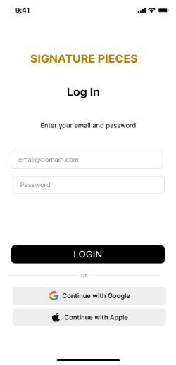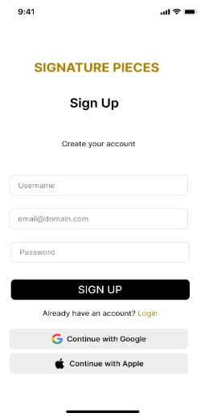****

If the users dose not have an account, they can sign up

Log in If the users have an account

The welcome screen lasts for 3 seconds

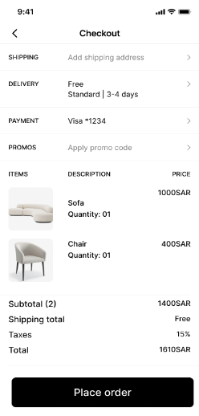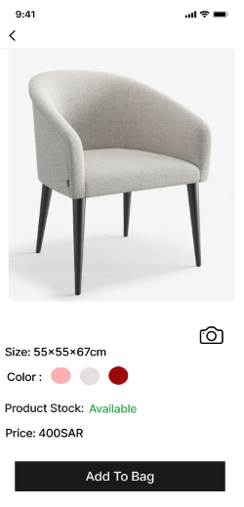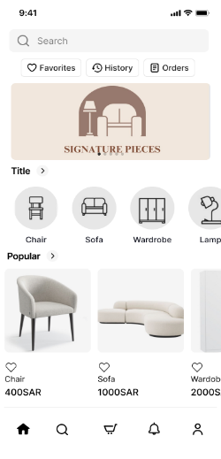

A furniture shopping main page with search, categories, and popular items. A banner ad promotes “SIGNATURE PIECES.” The bottom bar includes Home, Search, Cart, Notifications, and Profile icons.

Displays shipping, delivery, payment, and promo options. A “Place Order” button finalizes the purchase.

Displays products image, size, color options, stock status, and price. A black “Add To Bag” button allows users to purchase the item.

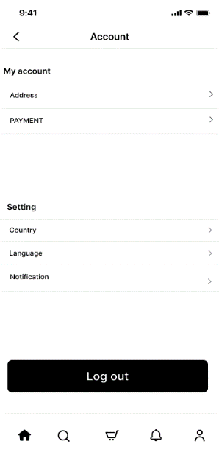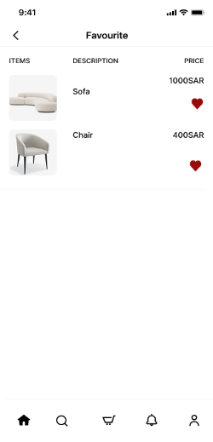

The Account displays various options under My account, including Address and payment. Below that, there are settings options such as Country, Language, and Notification. At the bottom, there's a prominent button labeled Log out.

Shows a list of favorited items with images, descriptions, and prices. Each item has a heart icon to add/remove from favorites.

Confirms that a purchase has been completed. Displays a thank-you message with a “Back to Home” button.

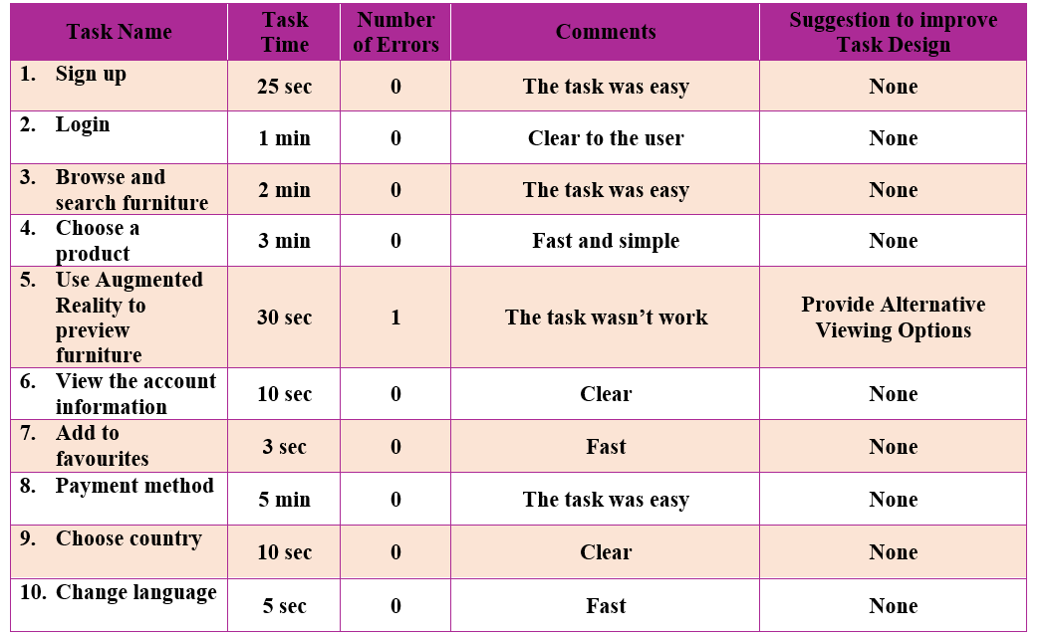

**Analysis of user1(Dana Alharbi) interaction:**

User 1 completed tasks easily, except for the AR furniture preview, which didn’t work. Everything else was fast and clear. The only improvement needed is fixing the AR feature.

**Analysis of user1(Dana Alharbi) interaction:**

User 1 completed tasks easily, except for the AR furniture preview, which didn’t work. Everything else was fast and clear. The only improvement needed is fixing the AR feature.

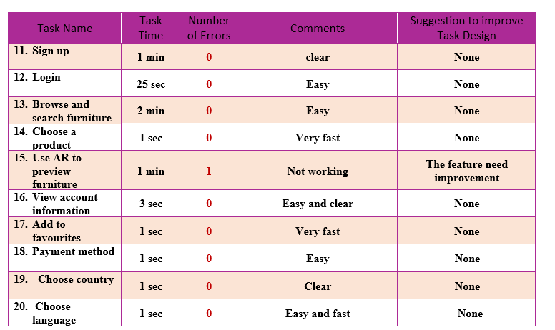

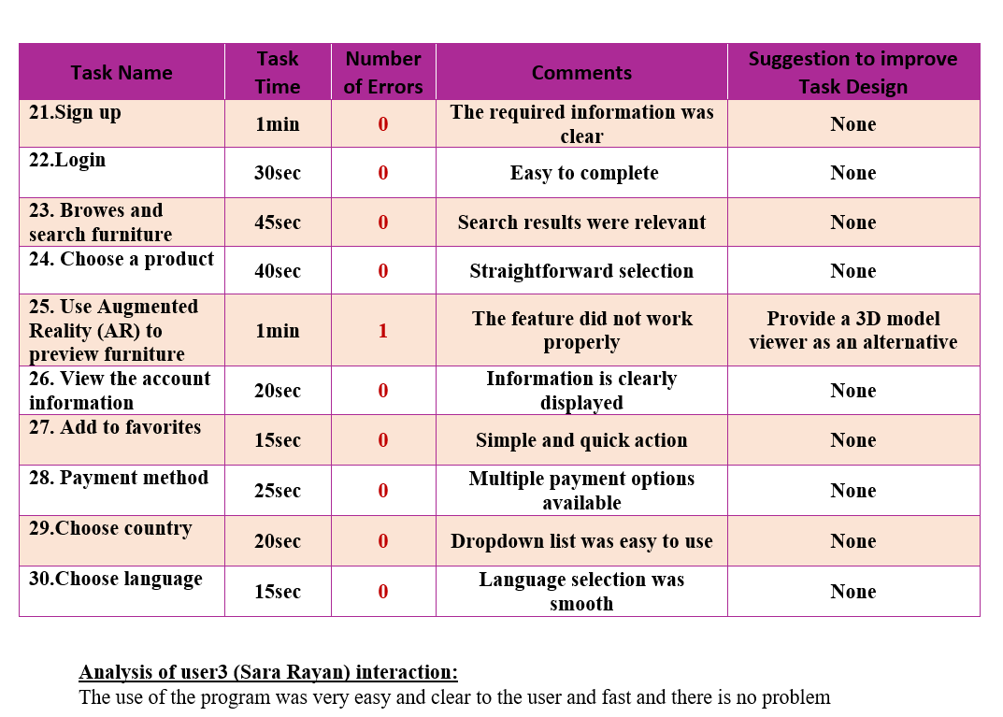**Analysis of user 2 ( Farah Naif ) interaction:**This user experience was smooth and fast, and all tasks work well except the augmented reality (AR) feature which needs to be improved.

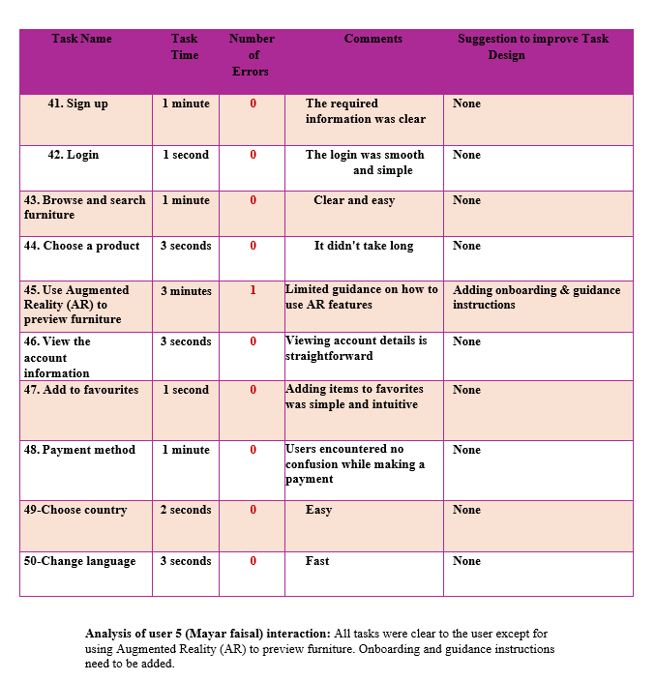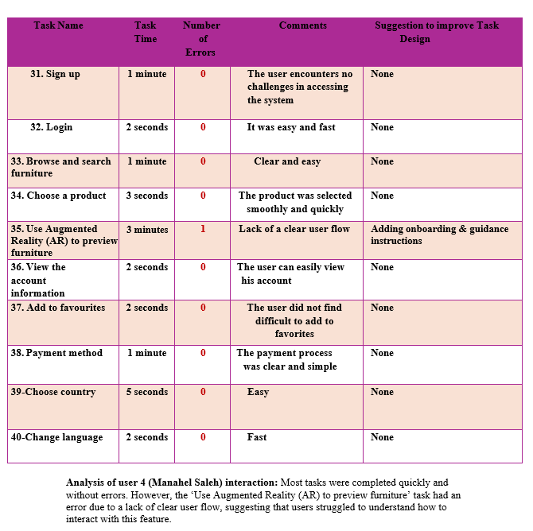

**4. Conclusions:**  
Considering the tables above, it is clear that our system will assist many users in accomplishing their tasks in a timely manner, and can be utilized by 90% of users. Nonetheless, 10% of users experienced problems due to the AR feature not meeting their expectations, which required some enhancement or alternative techniques of displaying the furniture.